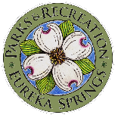
PARKS SUGGESTION FORM
Do you have a suggestion for our parks, springs or lakes? Write in your comments below and drop it off at the Parks office (532 Spring St.) or at the Lake Leatherwood Bait Shop or Visitors Center. You can also email this form or a photo of it to operations@eurekaparks.com. We appreciate your feedback!
NAME: ___________________________________________________________________________
EMAIL ADDRESS: __________________________________________________________________
PHONE NUMBER: __________________________________________________________________
SUGGESTIONS: ___________________________________________________________________
__________________________________________________________________________________
__________________________________________________________________________________
__________________________________________________________________________________
_________________________________________________________________________________

